CSE220: Data Structures (Lab)

Fall 2024

Lab Quiz - 05

Duration: 30 Minutes

| Name: | ID: | Section: |
| --- | --- | --- |

### **Question 1 [15 Points]**

In this task you are given a BST and a destination. You have to find the sum of all the values that come from the root till we reach the destination. If the destination does not exist in the BST then the output or the summation will be 0. **You will always be given a value as a destination that exists in the BST.**

Let's say you are given the following BST  
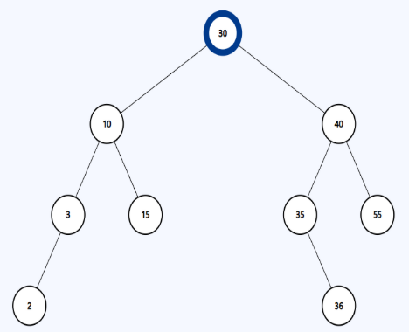

| **Sample Input** | **Sample Output** | **Explanation** |
| --- | --- | --- |
| find(root,36) | 105 | The route is 30->40->35->36. So sum is 30+40+35=105 |
| find(root,10) | 30 | The route is 30->10. So sum is 30 |
| find(root,3) | 40 | The route is 30->10->3. Sum=30+10=40 |
| find(root,30) | 0 | The root itself is the destination, so the sum is 0 |

**You need to construct the node class and the BST by yourself.**